Cross-quantilogram: NZDUSD and USDJPY
Method 20 / daily log returns / expanding quantiles / Alpari D1 full available history

Study setup
Logical pair: NZDUSD , USDJPY
Broker symbols: NZDUSD_i , USDJPY_i
Snapshot: 2026-11-03_majors_alpari_D1
Timeframe: D1
Matched return window: 1999-01-05 to 2026-11-02 (UTC bar dates)
Matched return count n: 7185
Dropped unfinished last bar dated 2026-11-03 UTC after a tick-volume check against the prior complete day.
Quantiles: expanding window, min history 252 days
tau in [0.05, 0.2]; k=0..10; headline tau=0.05, k=1
Complete matched rows (Excel): NZDUSD-USDJPY_CQ_D1.xlsx
Complete matched rows (HTML table): NZDUSD-USDJPY_CQ_D1_data.html

Method carried forward
The cross-quantilogram rho_tau(k) measures linkage among centered quantile-hit indicators of matched daily log returns of close, ln(close_t / close_t-1). Quotes are not inverted. At each date t, the tau-quantile uses only returns through t (expanding window) after a minimum history of 252 days. Hits are h_t = 1(r_t < q_t) - tau. rho_tau(k) is the normalized cross-product of h_x,t with h_y,t+k. Levels tau in {0.05, 0.20} and lags k=0..10 are pre-specified; headline is tau=0.05, k=1 both directions. Same-sample Pearson r is a side check. This is not causation and not a trading signal.

Results (headline)
rho_NZDUSD->USDJPY(tau=0.05,k=1): 0.020598
rho_USDJPY->NZDUSD(tau=0.05,k=1): 0.058472
rho_NZDUSD->USDJPY(tau=0.20,k=1): 0.040655
rho_USDJPY->NZDUSD(tau=0.20,k=1): 0.013171
Pearson r: -0.133568

CQ table (tau=0.05)
k | rho_NZDUSD_to_USDJPY | n_NZDUSD_to_USDJPY | rho_USDJPY_to_NZDUSD | n_USDJPY_to_NZDUSD
0 | 0.11012495 | 6934 | 0.11012495 | 6934
1 | 0.02059804 | 6933 | 0.05847156 | 6933
2 | 0.03436192 | 6932 | 0.04813423 | 6932
3 | 0.0309105 | 6931 | 0.04468293 | 6931
4 | 0.03778843 | 6930 | 0.02401588 | 6930
5 | 0.03089381 | 6929 | 0.01367798 | 6929
6 | -0.00698969 | 6928 | -0.00354649 | 6928
7 | 0.05153648 | 6927 | 0.05497971 | 6927
8 | 0.0377553 | 6926 | 0.02398228 | 6926
9 | 0.0170873 | 6925 | 0.00331416 | 6925
10 | 0.04118205 | 6924 | 0.06184194 | 6924

Conclusion
Headline tau=0.05, k=1 for NZDUSD and USDJPY: rho_NZDUSD->USDJPY = 0.0206; rho_USDJPY->NZDUSD = 0.0585. At tau=0.20, k=1: 0.0407 and 0.0132. Same-day tau=0.05 rho(k=0) = 0.1101. Pearson r = -0.1336. This is quantile-hit linkage, not a trading signal.

Charts
Daily closes

Daily log returns

Cross-quantilogram tau=0.05
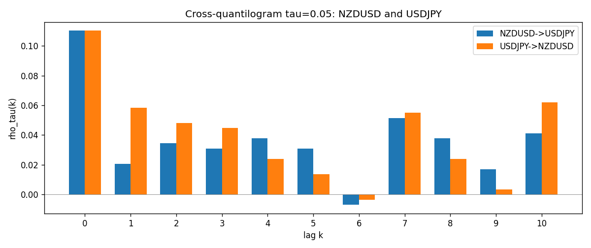

Data report
Matched rows and the CQ sheet are in the sibling Excel workbook named NZDUSD-USDJPY_CQ_D1.xlsx. Embedding all rows as a Word table is impractical; this file holds column summaries and the first and last 15 matched rows.
Columns: time, NZDUSD_open, USDJPY_open, NZDUSD_high, USDJPY_high, NZDUSD_low, USDJPY_low, NZDUSD_close, USDJPY_close, NZDUSD_tick_volume, USDJPY_tick_volume, NZDUSD_spread, USDJPY_spread, NZDUSD_real_volume, USDJPY_real_volume, NZDUSD_log_return, USDJPY_log_return, NZDUSD_h_t005, USDJPY_h_t005
Column summaries (matched calculation rows)
column | count | mean | std | min | 25% | 50% | 75% | max
NZDUSD_open | 7185 | 0.65641035 | 0.10820414 | 0.3913 | 0.59133 | 0.6684 | 0.72491 | 0.88218
USDJPY_open | 7185 | 113.80829 | 19.224285 | 75.693 | 104.39 | 110.98 | 120.695 | 163.824
NZDUSD_high | 7185 | 0.6603272 | 0.1086977 | 0.3961 | 0.59474 | 0.672 | 0.72936 | 0.88421
USDJPY_high | 7185 | 114.30556 | 19.28576 | 76.001 | 104.868 | 111.439 | 121.26 | 163.978
NZDUSD_low | 7185 | 0.65272421 | 0.10779902 | 0.3897 | 0.58806 | 0.66417 | 0.72098 | 0.87988
USDJPY_low | 7185 | 113.28523 | 19.152023 | 75.402 | 103.88 | 110.53 | 120.17 | 163.628
NZDUSD_close | 7185 | 0.65648647 | 0.10820164 | 0.3907 | 0.59157 | 0.6684 | 0.72502 | 0.8822
USDJPY_close | 7185 | 113.8211 | 19.239467 | 75.811 | 104.38 | 111.015 | 120.69 | 163.851
NZDUSD_tick_volume | 7185 | 68717.699 | 123140.61 | 16 | 5585 | 33899 | 58511 | 1127682
USDJPY_tick_volume | 7185 | 106344.18 | 179438.14 | 149 | 9948 | 53202 | 92889 | 1803508
NZDUSD_spread | 7185 | 30.280167 | 25.649381 | 0 | 9 | 17 | 40 | 80
USDJPY_spread | 7185 | 20.273626 | 17.623751 | 0 | 6 | 11 | 30 | 50
NZDUSD_real_volume | 7185 | 1.6703703e+10 | 8.4983725e+10 | 0 | 0 | 0 | 0 | 2.705649e+12
USDJPY_real_volume | 7185 | 3.4781051e+10 | 1.6093614e+11 | 0 | 0 | 0 | 0 | 3.8834203e+12
NZDUSD_log_return | 7185 | 1.284e-05 | 0.0076404 | -0.07027433 | -0.00425236 | 0.00022967 | 0.00458145 | 0.05966839
USDJPY_log_return | 7185 | 4.789e-05 | 0.00620418 | -0.03908203 | -0.00320044 | 0.00011802 | 0.00340223 | 0.05184024
NZDUSD_h_t005 | 6934 | -0.00543698 | 0.20635722 | -0.05 | -0.05 | -0.05 | -0.05 | 0.95
USDJPY_h_t005 | 6934 | -0.00702336 | 0.20281908 | -0.05 | -0.05 | -0.05 | -0.05 | 0.95
First 15 matched rows (selected columns)
time | NZDUSD_log_return | USDJPY_log_return | NZDUSD_h_t005 | USDJPY_h_t005
1999-01-05 | -0.0018597736 | -0.00017868311 | nan | nan
1999-01-06 | 0.0020455609 | 0.0075660159 | nan | nan
1999-01-07 | 0.0062963171 | -0.012851583 | nan | nan
1999-01-08 | -0.00055396548 | -0.0047719894 | nan | nan
1999-01-11 | 0.010290425 | -0.016195423 | nan | nan
1999-01-12 | -0.0053157489 | 0.032310364 | nan | nan
1999-01-13 | -0.0099742238 | 0.0081373171 | nan | nan
1999-01-14 | -0.00018564931 | 0 | nan | nan
1999-01-15 | -0.00074294208 | 0.0055343401 | nan | nan
1999-01-18 | -0.0018597736 | 8.7600193e-05 | nan | nan
1999-01-19 | 0.0018597736 | -0.0056219403 | nan | nan
1999-01-20 | 0.0040793678 | -0.0053879917 | nan | nan
1999-01-21 | 0.0040627941 | 0.0084664056 | nan | nan
1999-01-22 | -0.012051689 | 0.0060412564 | nan | nan
1999-01-25 | -0.0035504102 | -0.0073594164 | nan | nan
Last 15 matched rows (selected columns)
time | NZDUSD_log_return | USDJPY_log_return | NZDUSD_h_t005 | USDJPY_h_t005
2026-10-13 | 0.0047326165 | -0.0018932826 | -0.05 | -0.05
2026-10-14 | -0.0037306483 | 7.5800166e-05 | -0.05 | -0.05
2026-10-15 | 0.0047634855 | -0.0018524319 | -0.05 | -0.05
2026-10-16 | 0.0057501001 | -0.00037976126 | -0.05 | -0.05
2026-10-19 | 0.0018917133 | 0.0034946841 | -0.05 | -0.05
2026-10-20 | 0.0037199341 | -0.0022546642 | -0.05 | -0.05
2026-10-21 | 0.0030923331 | -0.00032883504 | -0.05 | -0.05
2026-10-22 | -0.0033035227 | -0.0085942669 | -0.05 | -0.05
2026-10-23 | 0.0030929853 | 0.00035080446 | -0.05 | -0.05
2026-10-26 | -0.0028993932 | 0.0041238746 | -0.05 | -0.05
2026-10-27 | -0.00026399852 | 0.0027651658 | -0.05 | -0.05
2026-10-28 | -0.0097283914 | -0.00095679538 | -0.05 | -0.05
2026-10-29 | 0.00062190714 | -0.00038043789 | -0.05 | -0.05
2026-10-30 | 0.00019537668 | -0.0010596481 | -0.05 | -0.05
2026-11-02 | -0.0025962955 | 0.0026438521 | -0.05 | -0.05

